Department of Computer Science & Engineering

Subject: Adhoc and Wireless Sensor Networks Lab

(BTCS 717-18)

B.Tech 4th Year- 7th Semester

Submitted to: Submitted by:



CGC College of Engineering

Landran, Mohali-140307

INDEX

SNO. | EXPERIMENTS | PAGE NO. | REMARKS
1. | Introduction of Wireless sensor network applications and its simulation | 2-29
2. | Network Simulator installation of wireless sensor network. | 30-34
3. | Implementation of routing protocol in NS2 for DSR protocol | 35-41
4. | Study other wireless sensor network simulators (Mannasim. Contiki) | 42-43
5. | Implementation of routing protocol in NS2 for AODV protocol for TORA protocol | 44-55

Experiment no 1
Aim: Introduction of Wireless sensor network applications and its simulation.
- Introduction of Wireless sensor network
A wireless sensor network consists of spatially distributed autonomous sensors to cooperatively monitor physical or environmental conditions, such as temperature, sound, vibration, pressure, motion or pollutants. The development of wireless sensor networks was motivated by military applications such as battlefield surveillance.
Sensor networks are composed of large numbers of tiny sensing and computing devices. Each of these devices, called motes, has very limited communication, computational and energy resources. Often embedded in uncontrolled physical environments, these networks require distributed algorithms for efficient data processing, while individual motes require highly concurrent and reactive behavior for efficient operation. Sensor networks face many problems that do not arise in other types of networks. Power constraints, limited hardware, decreased reliability, and a typically higher density and number of nodes than those found in conventional networks are few of the problems that have to be considered when developing protocols for use in sensor networks.
Figure.1.1 shows a typical simple wireless sensor network. As can be seen, a complete wireless sensor network usually consists of one or more base stations (or gateway), a number of sensor nodes, and the end user. Sensor nodes are used to measure physical quantities such as temperature, position, humidity, pressure etc. The output of those sensor nodes are wirelessly transmitted to the base station (or gateway) for data collection, analysis, and logging. End users may also be able to receive and manage the data from the sensor via a website from long-distance or applications in console terminal. However due to the associated cost, time and complexity involved in implementation of such networks, developers prefer to have first-hand information on feasibility and reflectivity crucial to the implementation of the system prior to the hardware implementation.
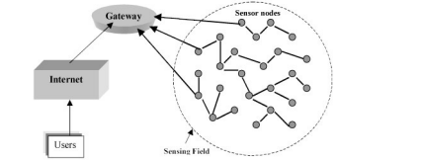
Figure 1.1Shows a typical simple wireless sensor network
This is especially true in sensor networks, where hardware may have to be purchased in large quantities and at high cost. Even with readily available sensor nodes, testing the network in the desired environment can be a time consuming and difficult task. Simulation-based testing can help to indicate whether or not the time and monetary investments are worthwhile. Simulation is, therefore, the most common approach to developing and testing new protocol for sensor networks. There are a number of advantages to this approach including lower cost, ease of implementation, and practicality of testing large-scale networks. In order to effectively develop any protocol based on simulations, it is important to know the different tools available and their benefits and drawbacks. Given the facts that simulation is not perfect and that there are a number of popular sensor network simulators available, thus making different simulators accurate and most effective for different situations/applications. It is crucial for a developer to choose a simulator that best fits the application. However, without a working knowledge of the available simulators, this is can be a challenging task. Additionally, knowing the weaknesses of available simulators could help developers to identify drawbacks of their own models, when compared with these simulators, thus providing an opportunity for improvement. It is thus imperative to have a detailed description of a number of the more prominent simulators available. In this paper, we have compared various sensor network simulators with emphasis on their ease of use, key features, limitations, availability, and environments best supported.
They are now used in many industrial and civilian application areas, including industrial process monitoring and control, machine health monitoring, environment and habitat monitoring, healthcare applications, home automation, and traffic control.
A smart sensor node is a combination of sensing, processing and communication technologies. Figure 1 shows the basic architectural components of a sensor node. The sensing unit senses the change of parameters, signal conditioning circuitry prepares the electrical signals to convert to the digital domain, the sensed analog signal is converted and is used as the input to the application algorithms or processing unit, the memory helps processing of tasks and the transceiver is used for communicating with other sensors or the base stations or sinks in WSN, see figure 1.2.
Sensors can monitor temperature, pressure, humidity, soil makeup, vehicular movement, noise levels, lighting conditions, the presence or absence of certain kinds of objects or substances, mechanical stress levels on attached objects, and other properties. Their mechanism may be seismic, magnetic, thermal, visual, infrared, acoustic, or radar. A smart sensor is also capable of self-identification and self-diagnosis. The mechanisms of smart sensors work in one of three ways: by a line of sight to the target (such as visual sensors), by proximity to target (such as seismic sensors), and by propagation like a wave with possible bending (such as acoustic sensors)
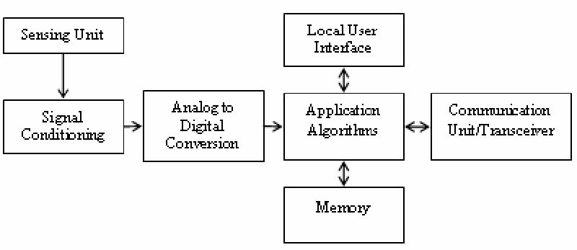
Figure 1.2: Basic architectural components of a smart sensor
DESIGN OF SENSOR NETWORK SIMULATOR:
The design of a Wireless Sensor Network (WSN) is a very application-specific task, especially because of the peculiarity of the considered deployment environment. Generic reliable predictive models for data correlation or radio propagation are seldom available. A thorough preliminary test phase is thus necessary, either by means of specifically crafted test beds, or via reliable simulations. WSN applications must be tested on a large scale, and under complex and varying conditions in order to capture a sufficiently wide range of interactions, both among nodes, and with the environment. A WSN simulator consists of various modules namely events, medium, environment, node, transceiver, protocols, and applications. Each category is represented by an interface that defines its methods and events generated and consumed.
1. Event
Event is an abstract base class that provides basic functionality for all events. It contains the time at which an event should work, and provides methods to: compare events based on their fire times, determine whether events are equal, print themselves to a string, and an abstract method to fire the event.
2. Medium
Medium models the wireless medium. It allows nodes to broadcast signals, and is responsible for informing nodes of signals that affect it. In order to do this, Medium must be informed of the presence of every node, and any changes in position or radio properties such as transmitter power or receiver sensitivity. Medium has the properties of bandwidth and wavelength of the medium modeled and a reference to a propagation model that is given to it at the time of construction. The propagation model provides the strength at a particular receiver from a signal transmitted by a given transmitter.
3. Environment
The Environment module is similar to Medium module. The difference is that the implementation of Environment has properties that relate to the physical phenomenon modeled. Environment also has a propagation model that models the propagation of the physical phenomena modeled. Physical phenomena of interest in sensor networks include: temperature, light, humidity, magnetic field, sound, optical, chemical presence.
4. Node
It represents a single node in a wireless sensor network. As such, it serves as a container for all of the components, both hardware and software, in a node. These components should be included: processor, transceiver, sensors, actuators, energy source (such as a battery), network protocols, and applications. In addition each node has the properties of location and identification.
5. Transceiver
Transceiver models the hardware transceiver on each sensor node. It models the transceiver states (i.e. sleep, standby, receive, and transmit), and their associated behavior and power consumption. Transceiver consumes events informing it of the beginning and ending of every signal it receives. It sums active signals to maintain the interference. Transceiver generates events for the beginning and ending of every signal it transmits. These events are all exchanged with an instance of the Medium module.
6. Physical Protocol
The Physical protocol is the lowest layer in a network stack. It is often implemented in the transceiver hardware. The Physical layer provides services for: changing the state of the transceiver, carrier sensing, sending and receiving packets, received energy detection on received packets, changing channels on physical layers that support multiple channels.
7. MAC Protocol
The MAC protocol is the next layer in a network stack. It is usually implemented in software running on the node’s processor. The MAC layer provides services for: changing the state of the MAC layer (i.e. low power mode), setting and getting protocol parameters, sending and receiving packets, etc. A WSN simulator usually offers implementations for several sensor network MAC protocols.
8. Routing Protocol
The Routing protocol resides above the MAC protocol and provides services for routing messages over multiple hops between nodes that cannot communicate directly.
9. Application Layer
The Application layer resides at the top of the network stack. It interfaces with the lower layers in the network stack as well as the sensors and actuators to implement a wireless sensor network application.
Most of the WSN simulators are based on the design described above. In addition to including the different modules, a WSN simulator should also have the following capabilities:
- Reusability and availability Simulation is used to test novel techniques in realistic and controlled scenarios. Researchers are usually interested in comparing the performance of a new technique against existing proposals.
- Performance and scalability Performance and scalability is a major concern when facing WSN simulation. The former is usually bounded to the programming language effectiveness. The latter is constrained to the memory, processor and logs storage size requirements.
- Support for rich-semantics scripting languages to define experiments and process results the vast amount of variables involved in the definition of a WSN experiment requires the use of specific input scripting languages, with high-level semantics. Additionally, it is likely that large quantities of output data will also be generated through many replicas of the experiments. Therefore, a suitable output scripting language, which helps to obtain the results from the experiments quickly and precisely, is desirable.
- Graphical, debug and trace support. Graphical support for simulations is interesting in three aspects:
(a) As a debugging aid. The primary and more practical way to quickly detect a bad behavior is to “watch” and follow the execution of a simulation. The key features that a graphical interface should support are: Capability of inspection of modules, variables and event queues at real time, together with “step-by-step” and “run-until” execution possibilities. These features make graphical interfaces a very powerful debugging tool. Note that the key is the ability to interact with the simulation.
(b) As a visual modeling and composition tool. This feature usually facilitates and speeds the design of small experiments or the composition of basic modules. However, for large scale simulations, it is not very practical.
(c) Finally, it allows quick visualization of results without a post-processing application.
However, there are various challenges associated with the available WSN simulators. For instance, some simulator lack of available protocol models, which causes the increase of developing time, some simulators limit the scalability, etc. Additionally, modeling problems arise when considering the new environment and the energy components. They also compromise scalability and accuracy. A deep study of these issues is mandatory for a better understanding and characterization of sensor networks and their corresponding simulators.

Wireless Sensor Network Architecture
The most common wireless sensor network architecture follows the OSI architecture Model. The architecture of the WSN includes five layers and three cross layers. Mostly in sensor n/w, we require five layers, namely application, transport, n/w, data link & physical layer. The three cross planes are namely power management, mobility management, and task management. These layers of the WSN are used to accomplish the n/w and make the sensors work together in order to raise the complete efficiency of the network. Please follow the below link for Types of wireless sensor networks and WSN topologies

Types of WSN Architectures
The architecture used in WSN is sensor network architecture. This kind of architecture is applicable in different places such as hospitals, schools, roads, buildings as well as it is used in different applications such as security management, disaster management & crisis management, etc. There are two types of architectures used in wireless sensor networks which include the following. There are 2 types of wireless sensor architectures: Layered Network Architecture, and Clustered Architecture. These are explained as following below.
- Layered Network Architecture
- Clustered Network Architecture

Layered Network Architecture:

This kind of network uses hundreds of sensor nodes as well as a base station. Here the arrangement of network nodes can be done into concentric layers. It comprises five layers as well as 3 cross layers which include the following.
The five layers in the architecture are:
- Application Layer
- Transport Layer
- Network Layer
- Data Link Layer
- Physical Layer

The three cross layers include the following:
- Power Management Plane
- Mobility Management Plane
- Task Management Plane
These three cross layers are mainly used for controlling the network as well as to make the sensors function as one in order to enhance the overall network efficiency. The above mentioned five layers of WSN are discussed below.
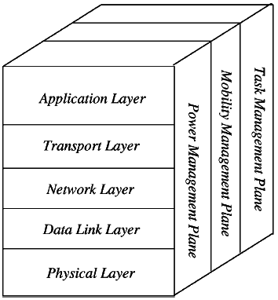
Figure 1 3: Wireless Sensor Network Architecture

Application Layer
The application layer is liable for traffic management and offers software for numerous applications that convert the data in a clear form to find positive information. Sensor networks arranged in numerous applications in different fields such as agricultural, military, environment, medical, etc.

Transport Layer
The function of the transport layer is to deliver congestion avoidance and reliability where a lot of protocols intended to offer this function are either practical on the upstream. These protocols use dissimilar mechanisms for loss recognition and loss recovery. The transport layer is exactly needed when a system is planned to contact other networks.
Providing a reliable loss recovery is more energy-efficient and that is one of the main reasons why TCP is not fit for WSN. In general, Transport layers can be separated into Packet driven, Event-driven. There are some popular protocols in the transport layer namely STCP (Sensor Transmission Control Protocol), PORT (Price-Oriented Reliable Transport Protocol and PSFQ (pump slow fetch quick).

Network Layer
The main function of the network layer is routing, it has a lot of tasks based on the application, but actually, the main tasks are in the power conserving, partial memory, buffers, and sensor don’t have a universal ID and have to be self-organized.
The simple idea of the routing protocol is to explain a reliable lane and redundant lanes, according to a convincing scale called a metric, which varies from protocol to protocol. There are a lot of existing protocols for this network layer, they can be separated into; flat routing and hierarchal routing or can be separated into time-driven, query-driven & event-driven.

Data Link Layer
The data link layer is liable for multiplexing data frame detection, data streams, MAC, & error control, confirm the reliability of point–point (or) point– multipoint.

Physical Layer
The physical layer provides an edge for transferring a stream of bits above the physical medium. This layer is responsible for the selection of frequency, generation of a carrier frequency, signal detection, Modulation & data encryption. IEEE 802.15.4 is suggested as typical for low rate particular areas & wireless sensor networks with low cost, power consumption, density, the range of communication to improve the battery life. CSMA/CA is used to support star & peer to peer topology. There are several versions of IEEE 802.15.4.V.
The main benefits of using this kind of architecture in WSN is that every node involves simply in less-distance, low- power transmissions to the neighboring nodes due to which power utilization is low as compared with other kinds of sensor network architecture. This kind of network is scalable as well as includes a high fault tolerance.

Wireless Sensor Network Applications
Wireless sensor networks may comprise numerous different types of sensors like low sampling rate, seismic, magnetic, thermal, visual, infrared, radar, and acoustic, which are clever to monitor a wide range of ambient situations. Sensor nodes are used for constant sensing, event ID, event detection & local control of actuators. The applications of wireless sensor networks mainly include health, military, environmental, home, & other commercial areas.
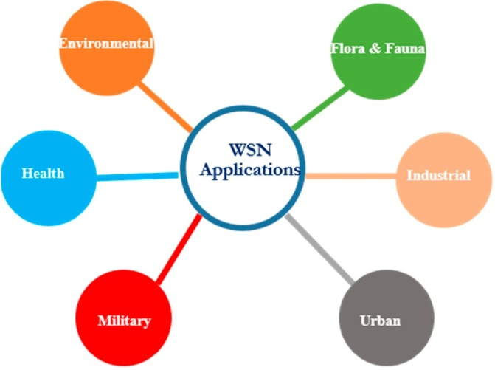
Figure 1.4. Overview of the most popular categories of applications of WSNs.
1) Military Applications: The military domain is not only the first field of human activity that used WSNs but it is also considered to have motivated the initiation of sensor network research. Smart Dust is a typical example of these initial research efforts, which were performed in the late 90 s in order to develop sensor nodes which despite their very small size would be capable of accomplishing spying activities
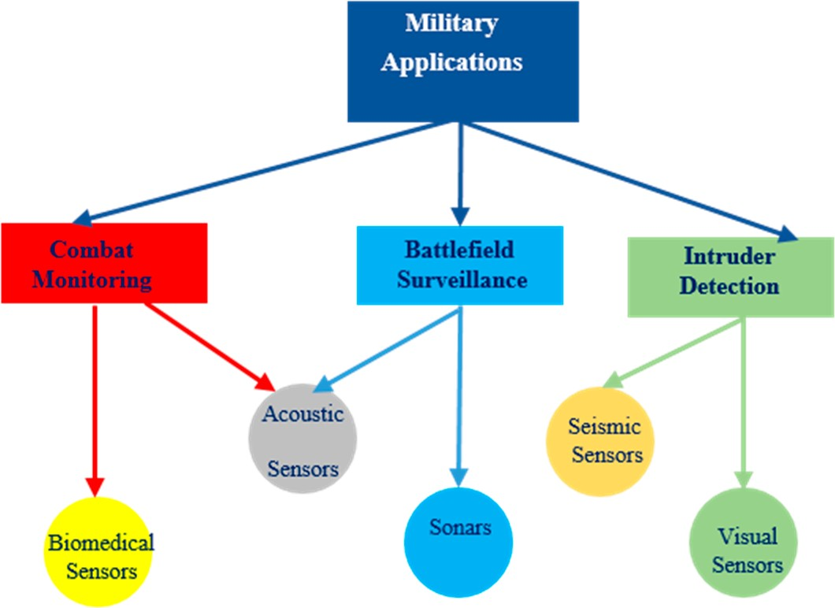
The technological advances achieved since then made WSNs capable of supporting various operations.

Figure 1.5.The subcategories of the military applications of WSNs and the types of sensors
InFigure 1.5,themainsubcategoriesofthemilitaryapplicationsofWSNswhichnamely arebattlefieldsurveillance,combatmonitoring,andintruderdetection,areillustratedalongwiththe types of sensors that are most commonly used inthem.
Specifically, Chemical, Biological, Radiological, Nuclear and Explosive (CBRNE), and Toxic Industrial Material (TIM) sensors may be used to detect the presence of such substances. To detect intrusion, WSNs may use infrared, photoelectric, laser, acoustic, and vibration sensors. Similarly, RAdio Detection and Ranging (RADAR), LIght Detection And Ranging (LIDAR), LAser Detection And Ranging (LADAR) and ultrasonic sensors are used by nodes in WSNs in order to detect the distance from objects of interest. Likewise, LADAR and infrared sensors are used for imaging purposes.
Additionally, the flexibility that WSNs have in their structure enables them to adapt to various requirements. For instance, in battlefield operations large-scale WSNs consisting of many thousands of nodes, which are non-manually deployed, are used. In urban warfare and force protection operations, WSNs used consist of hundreds of manually deployed nodes. In other-than-war operations all scales of WSNs and deployment methods are used.

WSNs that have been developed for battlefield surveillance, combat monitoring and intruder detection are examined in the following subsection.
  - BattlefieldSurveillance
Inapplicationsofthistype,thesensornodesoftheWSNmaybedeployedonabattlefieldnearby of the paths that enemy forces may use. The main advantage provided is that the WSN not onlycan be spontaneously positioned but also can function, without need for continuous attendance and maintenance.Theterrainofthebattlefieldinmostcasesisabsolutelyvariable. Thisplaysanimportant roleforboththecoverageandtheenergyconsumptionofthesensornodes.Someoftheseapplications are presentedbelow.
The use of WSN technology for ground surveillance is studied. Specifically, the authors proposeasystemthatconsistsoflow-costcommonnodeswhicharecapableofsensingmagneticand acousticsignalsproducedbyvariousmovingtargetobjects.Thesystemaimstodetectandcategorize various targets, such as vehicles and troop movements, based on the spatial differences of the signal strength detected by the sensors. Figure1.6 illustrates the architecture of this system.
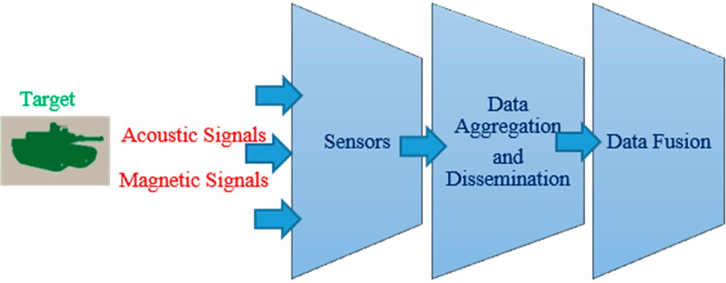
Figure 1.6.Illustration of the system architecture proposed in for target tracking.
InasubmarinedetectionsystemforAnti-SubmarineWarfare(ASW)ispresented.Thesystem consists of inexpensive multi-sensing units that combine both active and passive sonars. The system canbescaledtoalargenumberofsensors,whicharedeployedinlittoralwatersaccordingtoaspecific pattern and ocean depth. These sensing units utilize their passive sonar to detect a diesel-electric submarineandtheiractivesonartoconfirmtheirtarget.Theunitthathasconfirmedatargetnotifies its neighboring sensing units by using an alarm signal that contains its ID code. Whenever the units send multiple alarm signals within a predefined period of time, an alert is triggered. Furthermore, thesystemcanacquirelowFalseAlarmRate(FAR)duetotheverylowrangeoftheactivesonar(50m) that solves the acoustic multipath problem of the conventionalson buoys.
  - CombatMonitoring:
Withinabattlefieldthefiringofguns,mortarsartillery,andotherweaponrycreatessound,heat, andvibrations.ThisinformationcanberecordedwiththeuseofWSNsandprovidesanexpectationof the location of the enemy. This type of application is describedbelow.
Intheuseofacousticsensorarrayssuspendedbelowtetheredaerostatstodetectandlocalize moving vehicles, transient signals from mortars, artillery, small arms fire, and locate their source ispresented.
Thespecificdetectionsystemcanbeusedinconjunctionwithanacousticvectorsensor,toamplify the possibility of locating the threat using the shockwave created by the supersonic bullet and the muzzle blast created by the gun.
It describesasystemconsistingofinterconnectedBodySensorNetworks(BSNs), asub-familyofWSNs,forreal-timehealthmonitoringofsoldiers.Akeycomponentofthissystemisa BSNthatintegratesvariousphysiologicalandbiomedicalsensors. Thesesensorsareanaccelerometer, an EEG simulator, and a SpO₂sensor, which can be embedded within an advanced combat helmet worn by each soldier. They monitor the various information of health status in real time, such as blood pressure, oxygen saturation, and heart rate. By utilizing the data collected, various methods can be applied in order to train soldiers more efficiently and prepare them more adequately for futureengagements.
IntruderDetection: The knowledge of the location of the enemy is considered to be one of themost critical pieces of information during military operations. Whichever side in a conflict has this knowledge is one step aheadandclosertovictory.WiththeutilizationofWSNswithinabattlefield,intruderscanbedetected in good time to prevent loss of supplies orterritory.
An intruder can be detected in various ways. To detect an intruder, with the aid of these sensors, typical military activities,suchasequipmenthandling,walking,rifleloading,etc.,havebeenmeasuredandrecorded in a controlled environment and in the field. Although the distance of detection may be small, the informationprovidedbythenetworkcanbeusedtolocateanintruderindifficultterrainswithlarge vegetation where visibility islimited.
The application of WSNs, developed to detect intruders, is introduced. The authors describedasystemwithdensedeploymentofalargenumberofminiaturizedwirelesssensors,which are small, low cost, and consume low energy. This system utilizes acoustic and seismic sensors to provide detection information to the user and tracking and visual sensors in order to lower the false alarmrate.

  - HealthApplications:
In the health domain, WSNs utilize advanced medical sensors to monitor patients within a healthcare facility, as a hospital or within their home, as well as to provide real time monitoring of patient’s vitals by utilizing wearable hardware. In Figure7, the main subcategories of health applications of WSNs namely patient wearable monitoring, home assisting systems, and hospital patient monitoring are illustrated along with the types of sensors that are most commonly used in them. WSNs that have been developed for these types of health applications are examined in the followingsubsection.
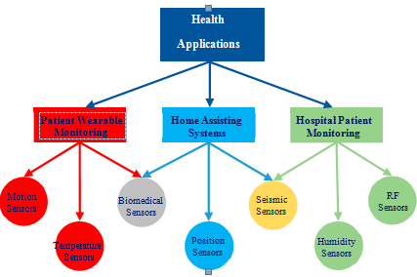

Figure 1.7.The subcategories of the health applications of WSNs and the sensors used in them.
Patient Wearable Monitoring: Health monitoring applications can be combined with wearable hardware with embedded biomedical sensors that provide the patient’s health status in a remote environment or within a healthcare facility.
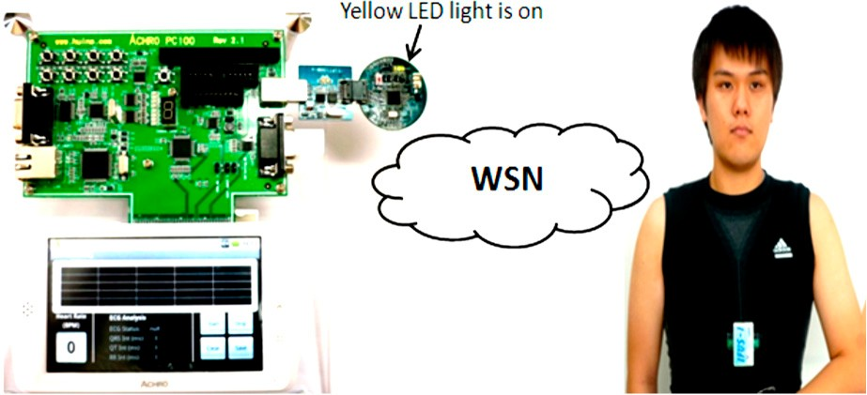
It uses real-time sensors incorporated in smartphones along with a barcode system to provide personalized medicine care assistance. The mechanism developed, performs Electrocardiogram (ECG) monitoring in real time. Also, the monitoring of the blood glucose level, blood pressure, and several kinds of diagnostics could be possible too, by using real-time sensors. This system developed is illustrated in Figure1.8.
Figure 1.8.An illustration of the real time electrocardiogram (ECG) monitoring environment

An alert portable tele-medical monitor system (AMON) is proposed in , aiming to provide continuous monitoring for high-risk cardiac/respiratory patients. The system collects multiple vital signs,detectsmulti-parametermedicalemergenciesandisconnectedtoacellulartelemedicinecenter (TMC). This system uses a wrist worn device, to monitor vital parameters of patients in order to provide an integrated picture of their healthcondition.
  - Home AssistingSystems :
A homecaremonitoringplatformwithinternetremoteconnectionto assisted people and their environment. This platform can monitor and diagnose patients remotely, in real time in their home environment by the utilization of wearable or even surgically inserted bio- sensors. A hybrid model of the platform is proposed, with various levels in terms of functionality, combining fixed and mobile nodes. These levels range from simple data acquisition of the assisted person to primary care and emergency nodes, up to the communication and coordination with an appointed help center as ahospital.
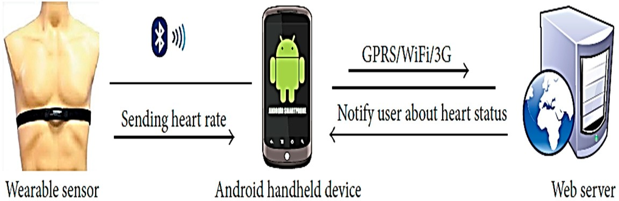
Oneofthe mainreasonsbehindthistechnologyistocommercializeitforthebenefitofthosepatientswhoarenot financially sound. Furthermore, the system was developed in such a manner that any kind of crisis phaseisdealtwithintermsofalertingmessagesthatareautomaticallysenttothedoctor.Anoverview of the operation of this system is shown inFigure1.9.
Figure 1.9.The system configuration of the remote patient monitoring application
  - Hospital Patient Monitoring (orHospitalization):
Within healthcare facilities, such as a hospital, WSNs systems can be integrated to provide real time patient monitoring and emergency alerting for a more precise and quick response. A WSN application where wireless sensors are placed within the emergency rooms of John Hopkins hospital to monitor in real time the blood oxygen and heart rate of the patients. The researchers collected the performance statistics of the network and despite the difficulty of the hospital environment due to interferenceandradionoise,theapplicationofWSNscanimprovetheoperationofahealthcarefacility. The device developed is depicted in Figure 1.10
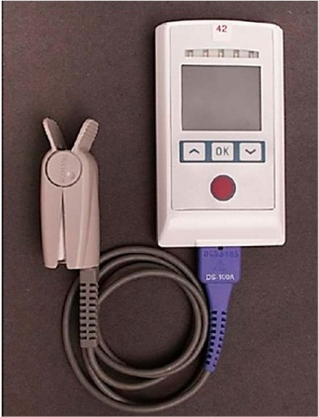
Figure 1.10.A monitor that can both display and transmit vital signs
- EnvironmentalApplications
Environmentalapplicationsthatdemandcontinuousmonitoringofambientconditionsathostile and remote areas can be improved with the utilization of WSNs. In Figure11, the main subcategories of environmental applications of WSNs, namely water monitoring, air monitoring, and emergency alerting,aredepictedalongwiththetypesofsensorsthataretypicallyusedinthem.WSNsthathave beendevelopedforthesetypesofenvironmentalapplicationsarestudiedinthefollowingsubsection.
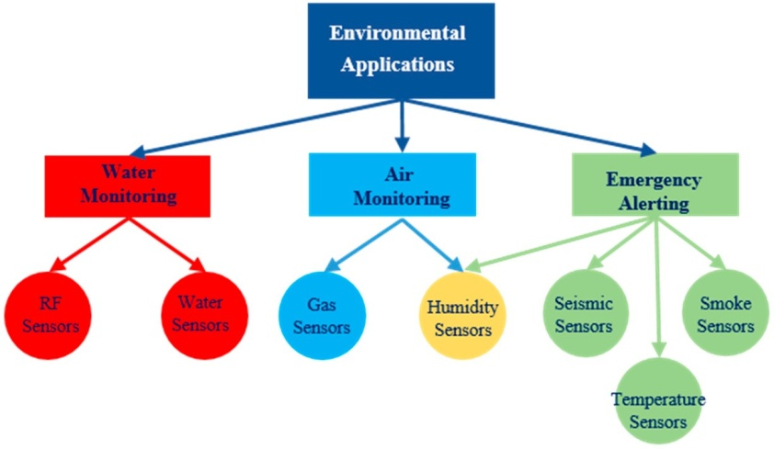
Figure1.11.ThesubcategoriesoftheenvironmentalWSNapplicationsandthetypesofthesensorsused inthem.
- WaterMonitoring
Water,eitherfordrinkingoroceanicisanimportantfactorinhumanlives;thereforethemonitoring of water has a great academic interest for researchers as describedbelow.
WSN application to evaluate the quality of fresh drinkable water. They designed a Cyber physical system (CPS) called PipeSense, which is an in-pipe system for water monitoring that utilizes RFID (Radio Frequency Identification) based WSN. The network can provide information about water demand or water quality and various repair information such as weak spots or pipe leakage. The in-pipe RFID sensors collect information from the system and send them to the data servers, where algorithms provide decision support.
In order to prevent damage to the flora and fauna of a fish farm from feed and fecal waste, the authors designed an Underwater WSN (UWSN) with ground based wireless sensor nodes capable of monitoring the pollutionofthefarm.Thesensornodesaremobileinalimitedspaceinordertomeasureagreaterarea.
- AirMonitoring
Airisavitalelementforhumanlivesandnowadaystheairpollutionoftheatmosphereisaresult ofmanymodernhumanactivities. WSNscanbeutilizedforairqualitymonitoringinoccupiedregions in order to prevent dangerous diseases and contaminations or risk the health ofpeople.
The specific system combinesgassensorsalongwithLibeliumwaspmotestomeasureairqualityparametersofgases such as ozone, CO, and NO₂. The waspmotes monitor in real time the air quality and utilize the Zigbee protocol for data communication. The authors further introduced the Clustering Protocol for Air Sensor network (CPAS) in order to support the operation of thissystem
- EmergencyAlerting
Proactive monitoring of the causes of natural disasters, can help to avoid these disasters or/and lowertheircost.WSNscanbeutilizedformonitoringcommondisastrouscausesinrealtimetoprovide proactivealertsinordertolowerdamageorevenpreventdisaster.Typicalexamplesdescribedinthe rest of this subsection, are related to the monitoring of seismic activity, volcanic activity, forest fires, andtsunamis.
- Seismic Activity Monitoring
Earthquakescancauseenormousdamagetoanoccupiedregionwheretheytakeplace.WSNscanbeutilizedtomonitorseismicactivityinrealtimeinordertotakeprecautionarymeasuresandenable the authorities to act in advance. A real time seismic activity monitoring systemispresented. Thesystemmonitorsseismicactivitybyutilizingprimarywaves(P-waves)andestimateslocalvelocityandthehypocenter’slocationaccordingtotimedelaysinthe arrival of the P-waves at the sensors. Volcanic Activity MonitoringVolcanoes can cause enormous damage to nearby towns or cities when they are activated. Beforeavolcanoerupts,therearemanysignsthataWSNsystemcanmeasure,proactively,inordertoinform nearby citizens about the eruption. When such a system is applied, citizens can protect their families and belongings by transporting them outside of the area of the eruption, preventing furtherdamage. Below is an example of such asystem.

Thesystemis lowcost,flexible,andeasytodeployandtomaintainforremotelocations.Theusersofthesystemcan chooseGPSdatasynchronizationwhenthesensornodeshavesignalreception,oraspecificalgorithm whentheyhavenot,tocollectaccuratetimestampsofeachsample.Piecesoftheequipmentused,are shown inFigure 1.12.
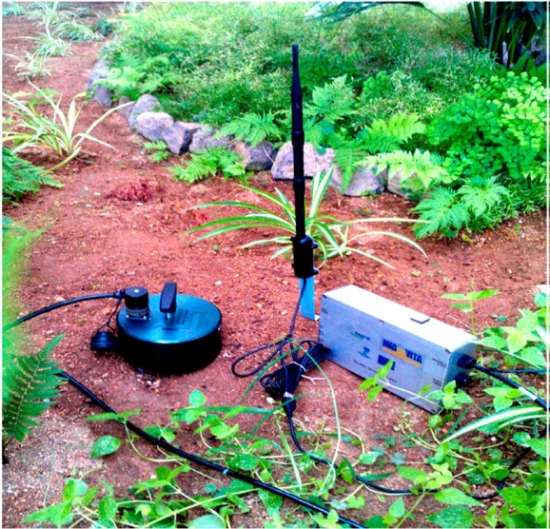
Figure 1.12.A depiction of a geophone sensor with a wireless antenna deployed in the field.
- Forest Fire Prevention
Forest fires can destroy both animals and vegetation, thus resulting in huge ecologicaldisasters. In order to prevent such disastrous events WSNs can be deployed within forests and monitor in real time related parameters in order to assist in forest fire prevention. One example of this type of WSN application is presented below.
Duetotherapidclimatechangetakingplace,thenecessityforproperforestfirepreventionmeans is extremely pressing. Relatedparametersastemperature,humidity,etc.aremonitoredinrealtimeandsenttoamonitoring centerinordertobeanalyzed.Thenthesystemcanmakequickestimationsoffiredangerandinform theauthorities.
- Tsunami Detection
Anothernaturaldisasteristhetsunamiwaves.Itiscrucialforcoastalregionstobeinformedearly of such a catastrophe. WSNs can be utilized for real time monitoring enabling the authorities to act proactively. Below a Tsunamidetection WSN application ispresented.
AtsunamidetectionsystemwhichutilizesaWSNwithunderwatersensornodesdeployed in coastal regions is proposed. In order to inform proactively the authorities, the system utilizes a lexicalresourcemessagingsystem,calledSentiWordNet,whichisabletoprovideinformationextracted from the sensormessages.

- Flora and FaunaApplications
Bothfloraandfaunadomainsarevitalforeverycountry.InFigure12,themainsubcategoriesoffloraandfaunaapplicationsofWSNswhichnamelyaregreenhousemonitoring,cropmonitoring,andlivestockfarming,areillustratedalongwiththetypesofsensorsthataremostcommonlyusedinthem.
WSNs that have been developed for these types of flora and fauna applications are examinedin the followingsubsection.
- GreenhouseMonitoring
An important sector of the agriculture domain involves greenhouses. Within them many crops can be grown to provide sustainable food while climate crops can be harvested all year round if certainconditionsareappliedwithinthegreenhouse.Therefore,WSNscanbeappliedingreenhouse monitoring and control to improve their operation. Below are some examples of theseapplications.
A system of this type, called the Agricultural Environment Monitoring System (AEMS), ispresented.Itisaninexpensiveandeasytoapplysystemthatcancollectandmonitordatarelatedto cropgrowth,insideoroutsideagreenhouseviaWSNsensorsandCCTVcameras.Thesystemgathers vital environmental parameters such as temperature, light intensity, humidity, air pressure, rainfall level, pH, and electrical conductivity(EC).
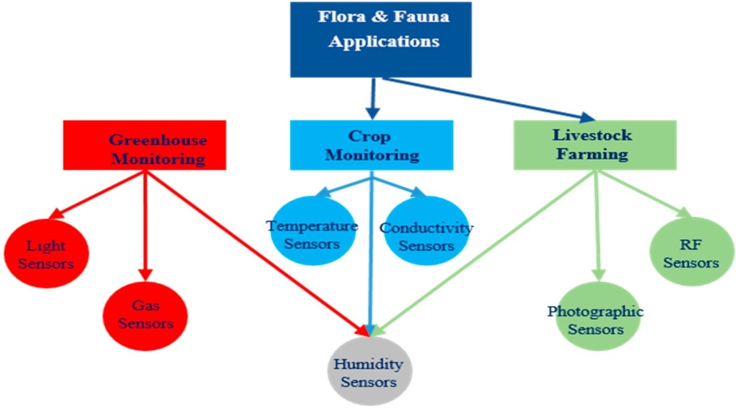

Figure1.13.ThesubcategoriesoffloraandfaunaapplicationsofWSNsandthetypesofthesensorsused inthem.
The system monitors vital greenhouse parameters such as indoor luminance, temperature, and relative humidity, via sensor nodes. The indoorclimate control is possible by the utilization of two fuzzy logic controllers, P (Proportional) and PD(Proportional-Derivative)thatusethedesiredindoorclimaticset-points.Furthermore,thesystem utilizesoutputactuationsofheatingunits,motor-controlledwindowsandshadingcurtains,artificial lighting, etc. in order to achieve more precise greenhousecontrol.
- CropMonitoring
Withintheagriculturedomain,thepreservationofthecropsplaysavitalrole.Inordertoprovide a better environment for the crops, various WSNs applications can be implemented. Crop irrigation andfertilizationaresomeexamplesoftheapplicationsthathavebeendesignedasdescribedbelow.
the systemusedB/Sa(browser/server)structuremodetoprovidehighinteractivity.Also,aGISanalysis serverwasusedtointerpolatethedatafromsmallexperimentalplotstolargerplotstoexploitdata reduction for energy conservation. An overview of the overall system architecture is illustrated in Figure1.14.
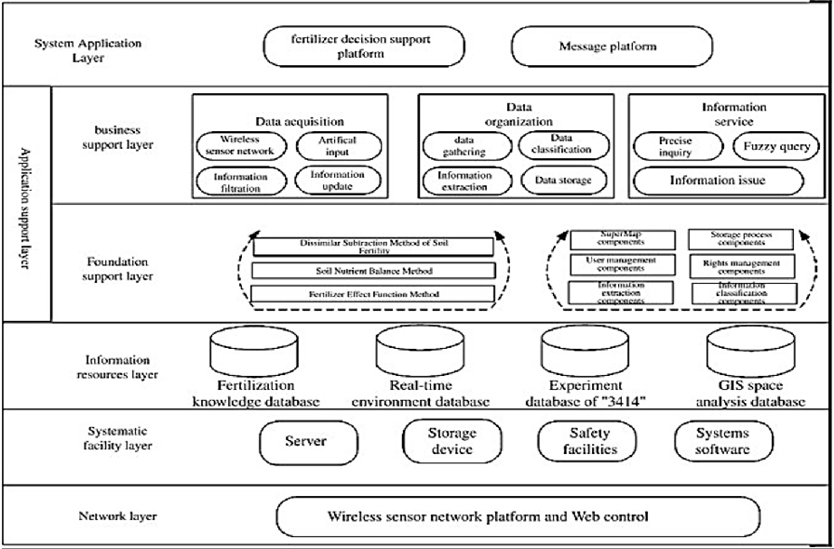
Figure 1.14.A structure diagram of the integrated optimal fertilization decision support system.
Thissystem aimsatefficientlymanagingwatersupplyincultivatedfieldsinanautomated way.Thesystemtakes intoconsiderationthehistoricaldataandthechangeintheclimatevaluestocalculatethequantityof water that is needed forirrigation.
- LivestockFarming
Livestock farming is a main sector of the fauna domain. WSNs can be applied in various tasks such as livestock monitoring. Below we have collected some examples of these applications.
Green pastures are used by cattle for grazing, so grass growth was analyzed through photographic sensors, so that animals can be moved towards them. Their major objective of work was to design rugged hardware that could be used outdoors for modeling both individual and herd behavior of animals. Although, specially designed sensors to monitor animal behavior, such as sleeping, grazing, and ruminating, are used, cattle monitoring still poses several challenges like radio attenuation caused due to factors such as animal body, mobilityetc.
The system developed uses a solar power relay router and two antennas placed so that the collar radio coverageisoptimized.Also,anovelprotocol,namedImplicitRoutingProtocol(IRP),wasproposedin order to cope with the packet losses, which are caused due to the mobility of theanimals.

3) IndustrialApplications:
WSNs can be applied in various industrial applications to solve many related problems. InFigure1.15,themainsubcategoriesofindustrialapplicationsofWSNsnamelylogistics,robotics,and machinery health monitoring are illustrated. These specific categories of applications are studied in the rest of this subsection.

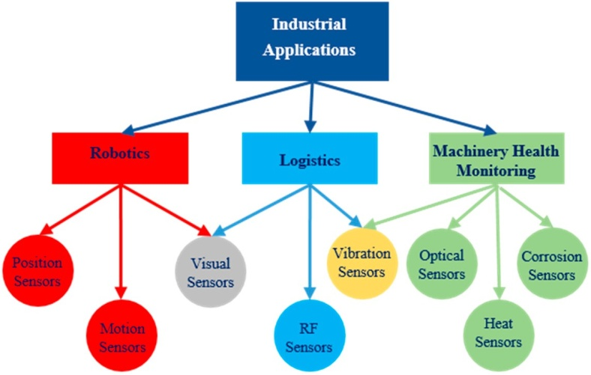
Figure 1.15.The subcategories of the industrial applications of WSNs and the types of the sensors used in them.
- Logistics
ThedomainoflogisticsisanareaofinterestwhereWSNscanbeapplied,becausemanylogistics systems need real time monitoring of various environmental parameters and better handling of packages. These requirements can be fulfilled by combining the logistics systems with WSNs. Some types of these applications are describedbelow.
The transport logistics sector requires low cost and high-quality during deliveries. the development and deployment of a WSN based system for monitoring transportation conditions, suchastemperatureandhumidity,withinacargocontainertravellingviabothatrans-Atlanticcargo vesselandalorryisdescribed.Themainideaforthedeploymentofthemonitoringsystemisdepicted in Figure 16. It is shown that the use of a system of this kind, can increase quality by providing better supervision and lower the cost by reducing losses duringtransportation.
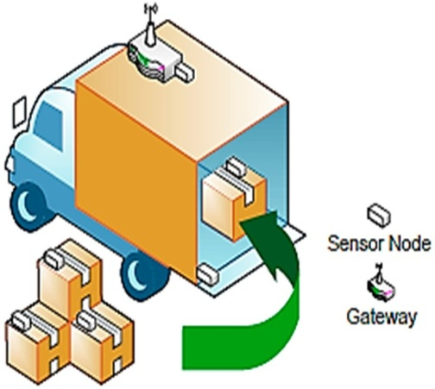
Figure 1.16.Depiction of the basic configuration of a WSN based system for transport logistics applications
The application of WSNs in Cold Chain Logistics (a continuous temperature-controlled supply chain) can greatly improve the monitoring and management of these chains. WSNs are suitable forrealtimemonitoringofmanyenvironmentalparametersandprovideaccuratedatacollectionthat meets the demand of Cold Chain Logistics. The researchers used a Zigbee ad hoc network model to build the system’s framework. By using fuzzy control decision, the environmental parameters aremaintainedinastablerangeandwithMaximumSimilaritiesMultipleCharacteristicRecognition (MSMCR) the safety of cold-chain food isensured.

- Robotics
Nowadays there are many applications that combine WSNs and robots. Robots can cooperate andcombatsomeofthemajorproblemsofWSNs,suchassensornodemobility, noderedeployment, travelling salesman, etc. Typical WSN applications of this kind are presentedbelow.
Specifically,each sensor constructs a map, based on the traversable area sensed. Then, all sensor maps are combined to create one large map. Once the road maps are generated, the sensors are used to sense areas of interest for the robot to travel to. The robot then considers all possible roads to take and selects the most efficient path available in the network. If an area becomes hazardous for the robot, the network canreconfiguretheroadmap,andremovethishazardousareafromthelistofavailablepaths.
- Machinery HealthMonitoring
Theobjectiveofmachineryhealthmonitoringistoexaminetheperformanceofvarioustypesof technicalequipmentandtoeitherdetectorpredicttheoccurrenceoffaultsthatareobstructiveoreven catastrophic for theiroperation.

- UrbanApplications
The variety of sensing abilities offered by WSNs also provides an opportunity to gain an unprecedented level of information about a target area, be it a room, a building, or outdoors. WSNs are indeed a tool to measure the spatial and temporal features of any phenomena within an urban environment, providing a limitless number of applications. The most popular applications of WSNs in the urban domain are related to smart homes, smart cities, transportation systems, and structural health monitoring, as depicted in Figure1.17 and further described in the rest of this subsection.

Motion Sensors
Gas & Smoke Sensors
Visual Sensors
Accelero- Optical
meters Sensors
Corrosion Sensors
Biomedical Sensors
Pressure Sensors
Acoustic Sensors
Strain Sensors
Structural Health Monitoring
Transportation Systems
Smart Cities
Smart Homes
Urban Applications
Figure 1.17.The subcategories of the urban applications of WSNs and the types of the sensors used inthem.

- SmartCities
In large cities monitoring of various parameters is crucial for the optimal life of the citizens. WSNshaveahugeamountofapplicationstoproviderealtimedatatotheauthoritiesfortheoptimal functionofa city.Specifically,increasedtransportationofpeoplecreatesproblemsandtimewastage, when a large number of vehicles is heading towards common destinations. WSNs can be utilized for monitoring in order to reduce traffic, indicate car parking spots, etc.
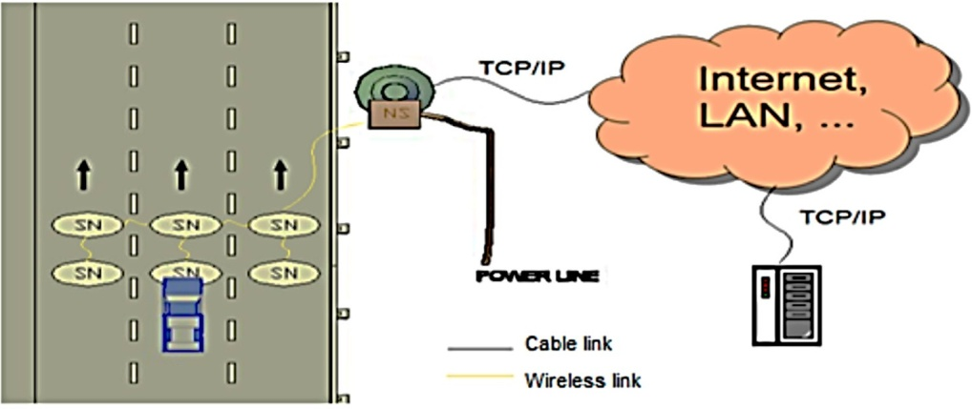
Figure 1.18.A depiction of the various setups where WSNs can be deployed

Thissystem enables the remote control of street lighting lamps, by using Doppler sensors to allow for vehicle detection.Thelightintensityofthelampsisincreased,toapresetlevel,inthepresenceofapproaching vehicles and reduced in the absence ofthem.
- SmartHomes
Intheeraofinformatics,varioussystemscanimprovehumanlives.Wirelesssensornetworkscan beappliedintheindoorenvironmentasinsmarthomeswheremachinetomachinecommunications takeplace.Twotypicalexamplesaretheindoorlocalizationandmotionmonitoringandthemonitoring of the indoor airquality.
Specifically,themonitoringofindoorairquality(IAQ),whichisatermthatreferstotheairquality of a building, has become, with the rapid urbanization process that is taking place, one of the most important topics of WSN urban applications. Modern people spend a great part of their life within a building, thus the air quality plays a critical role for their health, safety, and comfort
Similarly, the WSN based IAQ monitoring system usessensornodesthatmeasuretemperature,relativehumidity,andconcentrationofcarbondioxideinclassroomsinordertocorrelatethelevelofindoorairqualitywiththestudents’levelofperformanceintheirstudies.Theauthorsdevelopedasystem,whichisusedtoestimatethepositionofapersonwithinanindoorenvironment.Thesystemutilizesmobilesensornodeswornbythemovingpersonsandanetworkofstaticsensornodesatknownlocations.Tocalculatetheperson’sposition,thesystemgathers data from the nodes in a central PC and applies Monte Carlo based estimation algorithmsto track the moving persons in real time.
- TransportationSystems
Thetransportationofvehicleswithintheurbanenvironmentisanimportantfactorforthesafety and proper function of public roads. In the modern era various researchers have proposed many systems in the transportation domain, which by utilizing WSNs can improve the safety of roads and provide information during the use of them by drivers. Below we present some relative WSN applications applied in the transportationdomain
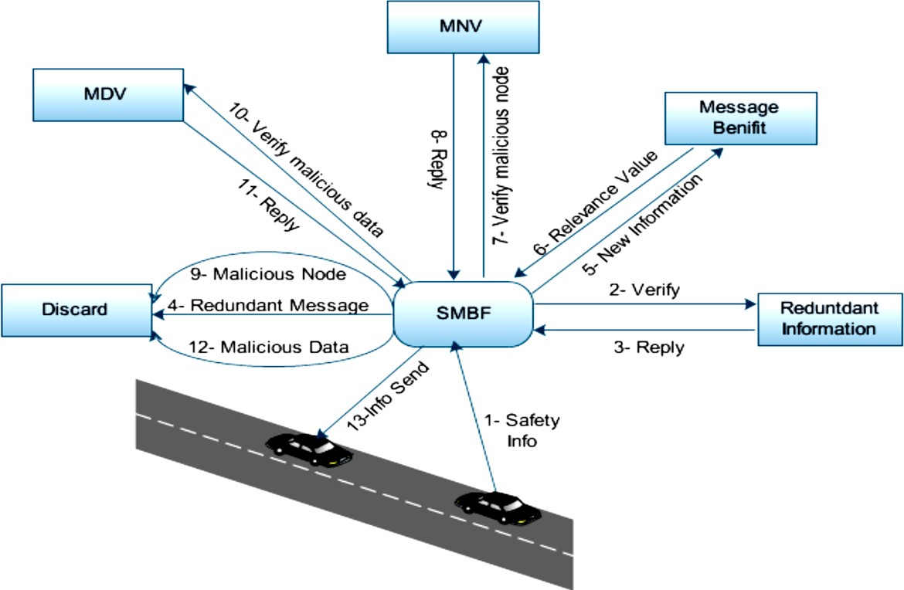
Figure 1.19.A representation of the Secure Multimedia Broadcast Framework (SMBP)
Thesystemutilizesdeployedsensornodesontheroadandasinknodeontheroadside. Thesensorsnodesdetectthepassingvehiclesandtransmitdatatothesinknode.Furthermore,when aneventoccursapacketiscreated,thesinknodeimplementsatimestamptoitandforwardsittothe comnode,whichutilizesalevel-basedstaticroutingprotocol.Next,thecomnodeforwardsthispacket totheuser,whichanalyzestheprovidedinformationinordertodeterminevariousmetricsoftheroad such as a vehicle’s speed, lane vehicle density etc. A depiction of the overall system configuration is shown inFigure1.20.
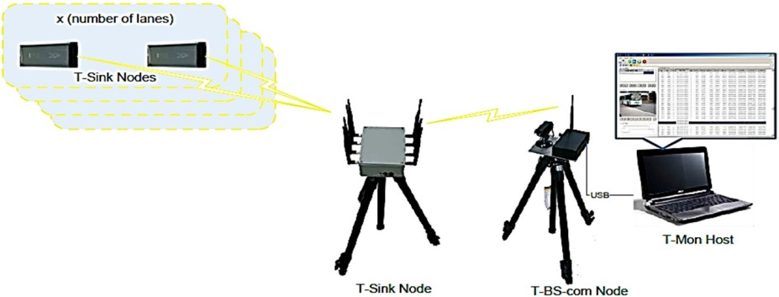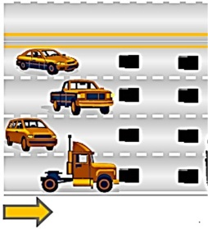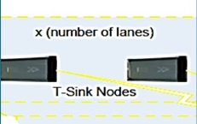
Figure 1.20.A graphical depiction of the WSN based transportation monitoring system

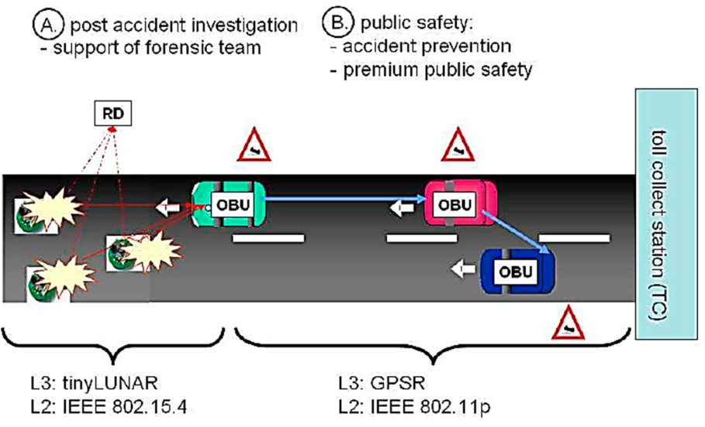
Inrecentyears,variousWSNhavebeendeployedwithincitiesresultingintheformationofsmall WSN based islandsFurthermore,theauthorsutilizetwowirelessstandardsi.e.,IEEE802.15.4andIEEE802.11pduetothe need for separate roadside sensor units. In order to prevent accidents, the WSN islands constantly detectroadconditionsandtransmitinformationtothevehiclespassingbythearea,whichaggregatethesedata.

Figure 1.21.An illustration of the WSN deployed for an Intelligent Transport system
Thenthevehiclethathasthisinformationtransmitswarningmessagestonearbyvehicles in order for the data to be disseminated along the road. The post-accident gathered information is restricted,bytheauthors,inordertobeusedonlybyauthorizedpersonnelsuchasinsurancecompanies, criminological teams, or other authorities. Moreover, according to the authors, the post-accident managementcanfunctionproperlybycommunicatingwiththeWSNislandsontheroadside,without the use of VANETs. The overall system operation is illustrated inFigure 21.
- Structural HealthMonitoring
TheaimofStructuralHealthMonitoring(SHM)inbuildingsandothertypesofcivilengineering substructures,istomonitortheirintegrityandtodetecttheexistenceandtheextentofdamagesinthe materialsor/andthestructureoftheirbodies.Theuseofwirelesssensorsfacilitatestheaccomplishment of tasks of this kind both in a periodic basis and after critical events (e.g.,earthquakes).
Specifically, a WSN incorporating nodes with appropriate sensors, such as accelerometers and strain gauges, was developed to monitor the restoration works carried out in an old church building located in Italy, which was damaged afteran earthquake. The system monitored the on the fly response of the structure to vibrations and enabled the transmission of alert signals whenneeded.
WSNbased,structuralhealthmonitoring platformforastadiumlocatedintheUSAisdescribed.Byusingvibrationsensing,thesystemcollects realtime,dataduringathleticandothermajoreventstoverifythestructuralbehaviorofthestadium, in correlation with the behavior of theaudience.

.
c) SIMULATION TOOLS:

This section illustrates main-stream simulation tools used in WSNs are Glomosim, NS-2, Sensor sim, prowler, omnet++, TOSSIM, EmStar, OMNeT++, J-Sim, ATEMU, and Avrora, and analyzes the advantage and disadvantage of each simulation tool. The network simulator is discrete event packet level simulator. The network simulator covers a very large number of application of different kind of protocols of different network types consisting of different network elements and traffic models. Network simulator is a package of tools that simulates behavior of networks such as creating network topologies, log events that happen under any load,analyze the events and understand the network.

NS-2
NS-2[12] is the abbreviation of Network simulator version two, which first been developed by 1989 using as the REAL network simulator. Now, NS-2 is supported by (DARPA) Defense Advanced Research Projects Agency and (NSF) National Science Foundation. NS-2 is a discrete event network simulator built in Object-Oriented extension of Tool Command Language and C++ [C++]. People can run NS-2 simulator on Linux Operating Systems or on Cygwin. This simulator is open source and provides online document. It helps to use network simulator and to get acquainted with the simulated objects and understand the operations of network simulation and we also need to analyze the behavior of the simulation object using network simulation. Steps followed to write a program
- Initialization and termination aspects of network simulator.
- Defining the network nodes, links, queues and topology as well.
- Defining the agents and their applications
- Network Animator(NAM)
- Tracing

Advantage
- Non-specific network simulator
- Open source it saves time and money and easy to modify and improve the code.
- It helps to increase the efficiency of simulation.
- It is used to provide details of the protocols and their operation.
- It is used to reduce packet and event processing time.
- OTcl helps in the following way:
- With the help of OTcl we can describe different network topologies
- It helps us to specify the protocols and their applications
- It allows fast development
- Tcl is compatible with many platforms and it is flexible for integration
- Tcl is very easy to use and it is available in free

Disadvantage
- Need to know Scripting language and modeling techniques
- TCL(Tool Command Language)
- More Complex sometimes to do desired job and time consuming than other.
- No GUI
- Continuous change of code base the result is not consistent.

TOSSIM
Tossim is an emulator specifically designed for WSN running on TinyOS, which is an open source operating system targeting embedded operating system. In 2003, TOSSIM was first developed by UC Berkeley’s TinyOS project team. TOSSIM is a bit-level discrete event network emulator built in Python [Python], a high-level programming language emphasizing code readability, and C++. People can run TOSSIM on Linux Operating Systems or on Cygwin on Windows. TOSSIM also provides open sources and online documents.

Advantage
- open source model free online document save the emulation cost
- support thousands of nodes simulation
- more accurately simulate the real world situation

Disadvantage
- TOSSIM’s run-instantly execution model does not capture CPU time.
- It does not model energy consumption, though there is an add-on

EmStar
EmStar is an emulator specifically designed in C for WSN, and it was first developed by University of California, Los Angeles. EmStar is a trace-driven emulator [Girod04] running in real-time. People can run this emulator on Linux operating system. This emulator supports to develop WSN application on better hardware sensors. Besides libraries, tools and services, an extension of Linux microkernel is included in EmStar emulator.

Advantage
- allows the users to run each module separately without sacrificing the reusability of the software
- Environment is flexible for deployment and simulation among sensors.
- It is GUI and it is helpful for users to control electronic devices.
- many online documents to facilities the widely use of this emulator

Disadvantage
- Only applicable to iPAQ-class sensor nodes and MICA2 motes
- Limited Scalability
- Does not support parallel simulation
- Not efficient as other frameworks

OMNeT++
OMNeT++ [14] is a discrete event network simulator built in C++. OMNeT++ provides both a noncommercial license, used at academic institutions or non-profit research organizations, and a commercial license, used at "for-profit" environments. This simulator supports module programming model. Users can run OMNeT++ simulator on Linux Operating Systems, Unix-like system and Windows. OMNeT++ is a popular non-specific network simulator, which can be used in both wire and wireless area. Most of frameworks and simulation models in OMNeT++ are open sources.

Advantage
- GUI
- support MAC protocols and localized protocol
- Channel control

J-Sim
J-Sim is a discrete event network simulator built in Java. This simulator provides GUI library, which facilities users to model or compile the Mathematical Modeling Language, a “text-based language” written to J-Sim models. J-Sim provides open source models and online documents. This simulator is commonly used in physiology and biomedicine areas, but it also can be used in WSN simulation. In addition, J-Sim can simulate real- time processes.

Advantage
- Reusability, interchangeability
- support MAC protocols and localized protocol
- supports around 500 nodes
- Independently platform
- more accurately simulate the real world situation

Disadvantage
- TOSSIM’s run-instantly execution model does not capture CPU time.
- It does not model energy consumption, though there is an add-on

ATEMU

ATEMU is an emulator of an AVR processor for WSN built in C; AVR is a single chip microcontroller commonly used in the MICA platform. ATEMU provides GUI, Xatdb; people can use this GUI to run codes on sensor nodes, debug codes and monitor program executions. People can run ATEMU on Solaris and Linux operating system. ATEMU is a specific emulator for WSNs; it can support users to run TinyOS on MICA2 hardware. ATEMU can emulate not only the communication among the sensors, but also every instruction implemented in each sensor. This emulator provides open sources and online documents.

Advantage
- Multiple nodes at the same time and each node can run different programs
- Large library with hard devices

Disadvantage
- Simulation time is much longer than other simulation tools
- Only few functions are used to simulate routing and clustering problems

Avrora
Avrora is a simulator specifically designed for WSNs built in Java. Similar to ATEMU, Avrora can also simulate AVR-based microcontroller MICA2 sensor nodes. This simulator was developed by University of California, Los Angeles Compilers Group. Avrora provides a wide range of tools that can be used in simulating WSNs.

Advantage
- It is a combination of TOSSIM and ATEMU simulators
- It supports for energy consumption
- It provides open source and online documents
- Supports faster speed and better scalability
- More accuracy than Tossim

Disadvantage
- Not have GUI
- It doesn’t support network communication tools

SENS
A Sensor Environment and Network Simulator. SENS is a wireless sensor network simulator with modular, layered architecture with customizable components which model an application, network communication, and the physical environment. It enables realistic simulations, by using values from real sensors to represent the behavior of component implementations. Such behavior includes sound and radio signal strength characteristics and power usage.

Advantage
- It is writtern in C++
- Platform independent
- WSN applications feature tight integration of computation, communication
- Interaction with the physical environment

Disadvantage
- Less customizable

COOJA (COntikiOsJAva)
COOJA is a simulator for the Contiki sensor node operating system. MSP Sim can be integrated into COOJA, forming COOJA/MSP Sim. It allows simultaneous cross-level simulation at application, operating system and machine code instruction set level. COOJA combines low level simulation of sensor node hardware and simulation of high-level behavior in a single simulation.

Advantage
- COOJA is flexible and extensible in that all levels of the system can be changed
- Sensor node platforms, operating system software, radio transceivers, and radio propagation models.
- COOJA is a Java application, all interaction with compiled Contiki code is done through Java Native Interface (JNI).

Disadvantage
- It is extensible and it is low efficiency
- GUI is absent and making extensible and time dependent difficult.

Castalia
Castalia is an application-level simulator for Wireless Sensor Network based on OMNeT++. It can be used to evaluate different platform characteristics for specific applications, since it is highly parametric, and can simulate a wide range of platforms. In Castalia, sensor nodes are implemented as compound modules, consisting of sub-modules that represent, for instance, network stack layers, application, and sensor.

Advantage
- sensing device noise, bias and node clock drift

Disadvantage
- Reliable and realistic framework for the first order validation of an algorithm before moving to implementation on a specific sensor platform.

Experiment no 2

Aim: Network Simulator installation of wireless sensor network.

Network Simulator 2 (NS2) : Installing NS2 On Windows 7
NS2 stands for Network Simulator Version 2. It is an open-source event-driven simulator designed specifically for research in computer communication networks.
NS2 uses OTcl to create and configure a network, and uses C++ to run simulation. All C++ codes need to be compiled and linked to create an executable file.
Use OTcl
- For configuration, setup, or one time simulation, or
- To run simulation with existing NS2 modules.
This option is preferable for most beginners, since it does not involve complicated internal mechanism of NS2. Unfortunately, existing NS2 modules are fairly limited. This option is perhaps not sufficient for most researchers.
Use C++
- When you are dealing with a packet, or - when you need to modify existing NS2 modules.
This option perhaps discourages most of the beginners from using NS2. This book particularly aims at helping the readers understand the structure of NS2 and feel more comfortable in modifying NS2 modules.

Installing NS2 on windows 7
NS2 builds and runs under windows using Cygwin. Cygwin provides Linux like environment under windows.
System Requirements: A computer with C++ compiler. Building full NS2 package requires large memory space approximately 250MB

I. Steps to install NS 2 on windows 7 are given below
1. Download Cygwin from following link https://www.cygwin.com/setup.exe
2. Run the downloaded setup.exe and you will see screen shown below click next.
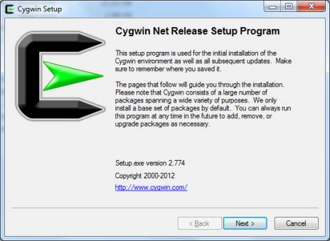
Figure 2.1
3. Select option "Install From Internet". If you have already downloaded the package select "Install from local directory" and click next
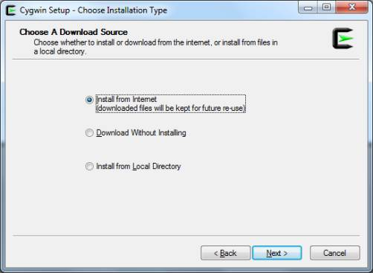
Figure: 2.2
4. Keep the default installation directory as "C:\cygwin" and click next
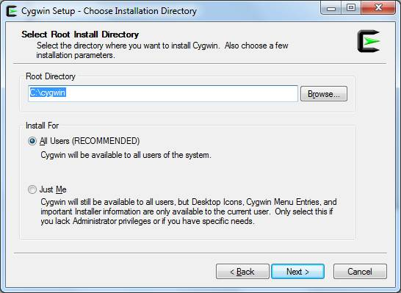
Figure 2.3
5. Keep default local package directory as your download folder and click next.
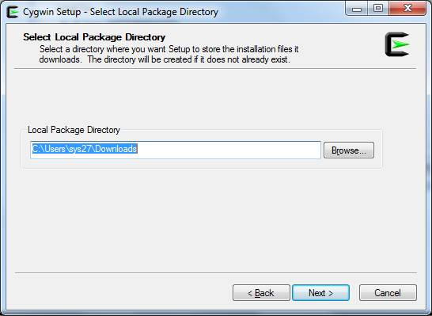

Figure 2.4

Network Simulator 2 (NS2) : Steps For Installing NS2
II. Steps is to install NS2
1. Download NS2 from following link: https://www.isi.edu/nsnam/dist/ns-allinone-2.28.tar.gz
2. Decompress the file use winrar. Copy the decompressed folder the Cygwin installation directory under the subdirectory home. It will be C:\cygwin\home\system_name : where system_name is name of your system in above Cygwin installation this path will be C:\Cygwin\home\sys27
3. Run Cygwin from desktop and change the directory to folder you copied just now in step 2 command to change directory:cd /home/sys27/ns-allinone-2.28
NOTE: please change sys27 to name of your system
4. To start installation type following command:"./install"(WITHOUT qoutes)
This will began the installation process if any Cygwin package is missing it will be reported to you if so the run Cygwin setu.exe and install the missing package and start again from step 2.
Installation is a long process and take quite some time once it is finished you will get a screen as shown below:
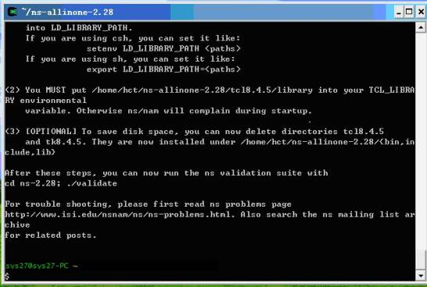
Figure 2.4
5. Add following lines to the .bashrc
export NS_HOME=/home/sys27/ns-allinone-2.28
export PATH=$NS_HOME/nam-1.11:$NS_HOME/tcl8.4.5/unix:$NS_HOME/tk8.4.5/unix:$NS_HOME/bin:$PATH
export LD_LIBRARY_PATH=$NS_HOME/tcl8.4.5/unix:$NS_HOME/tk8.4.5/unix:$NS_HOME/otcl-1.9:$NS_HOME/lib:$LD_LIBRARY_PATH
export TCL_LIBRARY=$NS_HOME/tcl8.4.5/library

NOTE: replace sys27 with your system name
6. To check if NS2 is installed correctly you can run one sample example given in ns-tutorials folder
To run the example change the directory to examples folder: cd ./home/sys27/ns-allinone-2.28/ns-tutorial/examples
Then type following command:
ns example2.tcl
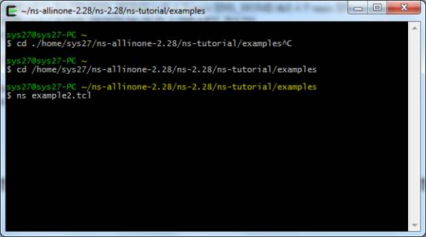
Figure 2.5

Experiment no 3

Aim: Implementation of routing protocol in NS2 for DSR protocol.

The Dynamic Source Routing protocol (DSR) is a simple and efficient Routing protocol designed specifically for use in multi-hop wireless mobile nodes networks called Ad hoc networks. DSR allows the network to be completely selforganizing and self-configuring, without the need for any existing network infrastructure or administration. This paper describe the design of our own implementation of DSR protocol using DSR MANET draft in NS2 simulator environment and provide a summary of some the simulation and testbed implementation results for the protocol.
The Dynamic Source Routing Protocol is a source-routed on-demand routing protocol. A node maintains route caches containing the source routes that it is aware of. The node updates entries in the route cache as and when it learns about new routes. DSR does not rely on functions like periodic routing advertisement, link status sensing or neighbor detection packets and because of the entirely on demand behavior, the number of overhead packets caused by DSR scales down to zero.

Source code:
Not all flies in ./dsr/ directory are used by the ns-2. the routing agent is implemented as Agent/DSRAgent.
Thus, the source codes include:
- dsragent.cc (h): DSR agent class. major state machine handling routings. Important variables; net_id, mac_id in ID type. (IP and MAC address), both of them are initialzied by tcl commands to set the initlavalie, the commads are "addr" amd "mac_addr"
- hdr_sr.cc(h): define hdr_sr class.
- request_table.cc(h)
- Path.h(cc): Path class. First, define struct ID, it has an unsigned long addr a enum of ID_type, and a time stamp t. and then in Path class, ID[] is the key members of the path, and operator [] is defined to return an element of ID array. thus whenever the SRPacket.route[n] will return to the reference of ID[n]. Other member variables include cur_index, len,
- srpacket.h: Just define SRPacketclass which enclose the hdr_sr as a full packet. The SRPacket construct has two parameters, a normal packet and a SR (Source Route) Header (a path variable). The constructor of "path" class makes a path from the bits of an NS source route header. And the other two variables of the SR packet are "dst" and "src" IP addresses.
Data Structure for Route
It is found that srh->addr and p.routeare two different structures. srh() is always along with the packet. however, when DSR agent received a packet, it will
SRPacketp(packet, srh);
This generate a "p" which is frequently used by all other functions. remember p does not go along with the packet leaving dsr agent. Before the packet was sent out of the agent, another statement will be used to update "SRH" in sendOutPacketwithRoute
p.route.fillSR(srh);
Also, the tap() entry is also generate a p for its use. however, another entry point of agent "xmitFailed" use srh() directly.
Special tcl interface.
Unless other routing protocol, the ns-2.1b9a,has a special node type named as "SRNodeNew". From those routines in the ns-lib.tcl. We can see that speical. Also, there is a tcl file in mobiloty/dsr.tcl is also related.
Simulator instproc create-node-instance args
{
$self instvarroutingAgent_
# DSR is a special case
if {$routingAgent_ == "DSR"}
{
set nodeclass [$self set-dsr-nodetype]
}
else
{
set nodeclass Node/MobileNode
}
return [eval new $nodeclass $args]
}
Simulator instproc set-dsr-nodetype {}
{
$self instvarwiredRouting_
set nodetypeSRNodeNew
# MIP mobilenode
if [Simulator set mobile_ip_] {
set nodetypeSRNodeNew/MIPMH
}
# basestationdsr node
if { [info exists wiredRouting_] && $wiredRouting_ == "ON"} {
set nodetype Node/MobileNode/BaseStationNode
}
return $nodetype
}
DSR Signaling Packets in Brief:
- route-request. the packet itself is a layer 3 packet with a unique destination address, but MAC_Broadcast (labeled in common header's next_hop())
- route-reply: unicasting in both layer 2 and 3.
- route-error. unicasting in both layer 2 and 3. Generated when tx_failure in lower layer.
Entry Points for DSR agent:
- first, as normal, the recv() function which means a packet with a address destine to this node or from upper-target.
- xmitFailed(). This is the callback function when a MAC transmission failes. Based on this chance, route-error message generated
- tap(). This is a hidden entry when you turn promiscuous on. snooping the route and shorten the path.
Basic functions:
- recv(), the entry for a receving packet. depends on the ip address of the packet and the SR (Source Route) header, call different functions to handle it. like the diagram below:
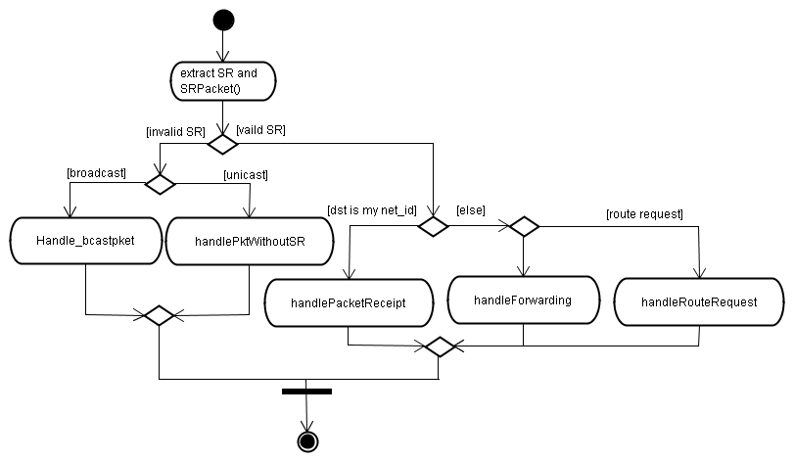Figure 3.1
- The route-reply, route-request messages need special handling routines written in the handlePacketReceipt() funciton. Note that if the RRequest message reached the destination, the receiptent should send a RReply message, this is done by a function named returnSrcRouteToRequestor(p) which is called in handlePacketReceipt(). Otherwise, if the route-request and route-error are not destined to us, for route-request, the function handleRouteRequest() is calledhandlePacketReceipt().
- A signaling reached its destination. There are two case:
  - if it is a route-request and "not processed", sends back a route-reply, pkt "p" is forged in this function and returnSrcRouteToRequestor(p)
  - if it is a route-reply, call functiuon acceptRouteReply(p);
- handleRouteRequest(): From the version 2.27, we see some unused codes but probably under develop for future versions. It includes more close mac-routing cooperation, such as neighbor identity (is_neighnor()), and channel status (air_time_free()).
Basically, this function has three branches:
  - already processed, checked by function ignoreRouteRequestp(p).
  - has a cached route, done by replyFromRouteCache(p), and "cached route" is enabled by the flag dsragent_reply_from_cache_on_propagating.
  - append myself in route with p.route.appendToPath(net_id); and sendOutPacketWithRoute(p, false);
- handleForwarding. Forward packet on to next host in source route and snooping as appropriate. So, a route-reply message is not treat as exceptional. It is a normal packet with sr header and be snooped by this node. The snooping is enabled by the flag "dsragent_snoop_source_routes" .
handleForwarding is dcallin "handleDefaultforwarding" for doing some simple operations for DSR rules. At last, the packet will be sent by sendOutPacketWithRoute
- sendOutPacketWithRoute: The function is used as for send packets, Take packet and send it out, packet must a have a route in it. return value is not very meaningful. if fresh is true then reset the path before using it, if fresh is false then our caller wants us use a path with the index set as it currently is. Basically,
  - cmn header's failure callback functon and data are set
  - cmn header 's next hop is set to addr of next-hop in dsr header. address type are also set.
  - move the pointer in SR header to the next (increase 1).
Actually, the third operation is not valid in real DSR implementations. To undo this effect in error-handing, we'd better find current Ip address first and locate the position of this address in SR header. The other two operations are also invalid, because there are no common headers in a real packet. For the "next_hop()" in common header, it is used by DSR only for those packets without valid SR header, refer to recv().
- returnSrcRouteToRequestor(); this function
- xmitFailed(): when the common header->xmit_failure_ point to a callback function, thus, when the packet cannot be delivered, the callback function is used, and finally will generate a route-error messages. There is always a pointer in the SR header curr() . ( Refer to manet-ietf-dsr draft, there is no such a pointer in DSR Source Route Option, but has a "segments left" field to indicate how many nodes still to visit to reach the destination. ). Thus, an innovation needs to be done to re-interprete the "srh->cur_addr()" as a index number of the position in the path where fail happens. So, when not all nodes along the path handle the SR header, we need find the ip address of the node from srh. and set that index as cur_addr();
- processBrokenRouteError(p); This should be another branch under the main recv() entry. It gives what to do when a Route Error message is receoived or heard (snooped). Snoop means the message was sent to another node but it passes myself, so i heard it.
- tap(const Packet *packet): This is another entry point for DSR. When dsragent_use_tap flag is true. the mac is working in promiscuous mode and all overhearing packets will be processed if there is a SR header in it.
Other:
The longest route we can handle is defined in : define MAX_SR_LEN 16 // longest source route we can handle
Possible Reason for xmit_failure below IP layer:
- arp failure
- interface queue is full
- mac transmission failure ( exceed the retry-limit)
DSR scheme options:
In the beginning of dsragent.cc, it define many bool selectors of some options like:
/*************** selectors ******************/
bool dsragent_snoop_forwarded_errors = true;
// give errors we forward to our cache?
booldsragent_snoop_source_routes = true;
// should we snoop on any source routes we see?
booldsragent_reply_only_to_first_rtreq = false;
// should we only respond to the first route request we receive from a host?
booldsragent_propagate_last_error = true;
// should we take the data from the last route error msg sent to us
// and propagate it around on the next propagating route request we do?
// this is aka grat route error propagation
bool dsragent_send_grat_replies = true;
// should we send gratuitous replies to effect route shortening?
booldsragent_salvage_with_cache = true;
// should we consult our cache for a route if we get a xmitfailure
// and salvage the packet using the route if possible
bool dsragent_use_tap = true;
// should we listen to a promiscuous tap?
booldsragent_reply_from_cache_on_propagating = true;
// should we consult the route cache before propagating rtreq's and
// answer if possible?
booldsragent_ring_zero_search = true;
// should we send a non-propagating route request as the first action
// in each route discovery action?
// NOTE: to completely turn off replying from cache, you should
// set both dsragent_ring_zero_search and
// dsragent_reply_from_cache_on_propagating to false
bool dsragent_dont_salvage_bad_replies = true;
// if we have an xmit failure on a packet, and the packet contains a
// route reply, should we scan the reply to see if contains the dead link?
// if it does, we won't salvage the packet unless there's something aside
// from a reply in it (in which case we salvage, but cut out the rt reply)
bool dsragent_require_bi_routes = true;
// do we need to have bidirectional source routes?
// [XXX this flag doesn't control all the behaviors and code that assume
// bidirectional links -dam 5/14/98]
#if 0
bool lsnode_holdoff_rt_reply = true;
// if we have a cached route to reply to route_request with, should we
// hold off and not send it for a while?
boollsnode_require_use = true;
// do we require ourselves to hear a route requestor use a route
// before we withold our route, or is merely hearing another (better)
// route reply enough?
#endif

About Flow State:
It is also desirable to disable the flow state stuff. it make the dsr code messy. flow state is not an orginal idea.
staticconst bool dsragent_enable_flowstate = false;
staticconst bool dsragent_prefer_default_flow = false;

Experiment no 4
Aim: Study other wireless sensor network simulators (Mannasim. Contiki)
Simulator Mannasim: Mannasim simulation environment for WSN is actually a framework based on foregoing ns2. Finding some useful information about Mannasim is difficult and the documentation is unclear according to the opinion of the author of this thesis. This section describes how can Mannasim be utilized with ns-2. It consists of two following parts:
Mannasim Framework – The Mannasim Framework is a module for WSN simulation which extends ns-2 introducing new modules for design, development and analysis of different WSN applications.
Script Generator Tool – The Script Generator Tool (SGT) is a front-end for Tcl simulation scripts easy creation. It is written in Java.
Mannasim Framework:
Mannasim provides twelve files which contain classes that extend corresponding native classes of ns-2. A class called SensorNode extends a class MobileNode of ns-2 and specifies several sensor characteristics like power consumption for sensing and processing, the number of instructions executed per seconds by its microcontroller or states of different sensor parts. This class can be used as initial approach for different sensor node types development.
A Battery class extends the EnergyModel of ns-2. It can be used to implement different existing battery models. It provides methods like turning sensor node on and off, it can put it into a sleep mode and it can decrease energy when the sensor performs sensing, processing or disseminating.
DataGenerator simulates the sensing task. Sensing interval may be adjusted and some classes for specialized sensing may extend this class. TemperatureDataGenerator and TemperatureAppData are examples of such extensions and add characteristics proper for temperature data and methods to work with the gathered data.
A Processing class simulates processing of the sensed data in every single sensor node. It provides methods for data aggregation, dissemination etc.
After processing, the data are represented by SensedData class. It is ready for dissemination and provides, among others, information like source node identification, message type or message priority.
OnDemandData and OnDemandParameter can be used for representing messages for the user of the simulated WSN. The former class deals with such messages while the latter is used for querying them according to a given parameter. A SensorBaseApp and its children CommonNodeApp and ClusterHeadApp are classes that represent different applications for WSN.

Contiki:Contiki is another open-source operating system for embedded systems and wireless sensor networks which is being developed at Swedish Institute of Computer Science lead by software engineer Adam Dunkels. It provides both full IP (Internet Protocol) networking and low-power radio communication mechanisms. Contiki is written in C.
Hardware Support: Contiki can be run on several different hardware platforms. Tmote Sky is probably the most known one based on a microchip MSP430 and using radio chip CC2420. Another platform suitable for Contiki is ESB (Embedded Sensor Board) also based on MSP430 and using TR1001 low-power radio transceiver. It is equipped with several kinds of sensors like sound, vibration, movement or temperature detection. The ESB has been developed at the Free University of Berlin and maintained by Scatterweb. A protocol uIPv6 (micro Internet Protocol version 6; described in the next section) has been successfully tested on Atmel AVR Raven platform.
Protocol Support: As it was already outlined, Contiki is particularly aimed to provide IP communication for low-power sensor networks. Both IPv4 and IPv6 are supported thanks to uIPv4 and uIPv6 implementations and also thanks to the so-called 6lowpan mechanism which is used to compress and frame packets to be transmitted more efficiently over IEEE 802.15.4 radio link. RPL, which has been discussed in section D.1, is implemented for Contiki as well.

Experiment no: 5

Aim: Implementation of routing protocol in NS2 for AODV protocol for TORA protocol

Part A: AODV Protocol
Steps involved in AODV routing protocol:
- Path discovery
- Reverse path setup
  - Forward path setup
- Rout table management
- Path maintenance
- Local connectivity management

Advantages of NS2 Simulation Code for AODV:
- Scalable to large population of nodes.
- Broadcast is minimized.
- Reduces memory requirements and needless duplications.
- Loop-free routes are maintained by use of destination sequence number.
- Nose store only the routes that are needed.

Simple AODV simulation in NS2 code
# Define options
set val(chan) Channel/WirelessChannel ;# channel type
set val(prop) Propagation/TwoRayGround ;# radio-propagation model
set val(netif) Phy/WirelessPhy ;# network interface type
set val(mac) Mac/802_11 ;# MAC Type
set val(ifq) Queue/DropTail/PriQueue ;# interface queue type
set val(ll) LL ;# link layer type
set val(ant) Antenna/OmniAntenna ;# antenna model
set val(ifqlen) 50 ;# max packet in ifq
set val(nn) 25 ;# number of mobilnodes
set val(rp) AODV ;# routing protocol
set val(x) 500 ;# X dimensions of topography
set val(y) 400 ;# Y dimensions of topography
set val(stop) 150 ;# time of simulation end
set ns [new Simulator]
set tracefd [open testAODV.tr w]
set windowVsTime2 [open win.tr w]
set namtrace [open testAODV.nam w]
$ns trace-all $tracefd
$ns namtrace-all-wireless $namtrace $val(x) $val(y)
#set up topography object
set topo [new Topography]
$topo load_flatgrid $val(x) $val(y)
create-god $val(nn)
#
# Create nnmobilenodes [$val(nn)] and attach them to the channel.
#
# configure the nodes
$ns node-config -adhocRouting $val(rp) \
-llType $val(ll) \
-macType $val(mac) \
-ifqType $val(ifq) \
-ifqLen $val(ifqlen) \
-antType $val(ant) \
-propType $val(prop) \
-phyType $val(netif) \
-channelType $val(chan) \
-topoInstance $topo \
-agentTrace ON \
-routerTrace ON \
-macTrace OFF \
-movementTrace ON
for {set i 0} {$i< $val(nn) } { incri } {
set node_($i) [$ns node]
$node_($i) set X_ [ expr 10+round(rand()*480) ]
$node_($i) set Y_ [ expr 10+round(rand()*380) ]
$node_($i) set Z_ 0.0
}
for {set i 0} {$i< $val(nn) } { incri } {
$ns at [ expr 15+round(rand()*60) ] "$node_($i) setdest [ expr 10+round(rand()*480) ] [ expr 10+round(rand()*380) ] [ expr 2+round(rand()*15) ]"
}
# Generation of movements
# $ns at 10.0 "$node_(0) setdest 250.0 250.0 3.0"
# $ns at 15.0 "$node_(1) setdest 45.0 285.0 5.0"
# $ns at 70.0 "$node_(2) setdest 480.0 300.0 5.0"
# $ns at 20.0 "$node_(3) setdest 200.0 200.0 5.0"
# $ns at 25.0 "$node_(4) setdest 50.0 50.0 10.0"
# $ns at 60.0 "$node_(5) setdest 150.0 70.0 2.0"
# $ns at 90.0 "$node_(6) setdest 380.0 150.0 8.0"
# $ns at 42.0 "$node_(7) setdest 200.0 100.0 15.0"
# $ns at 55.0 "$node_(8) setdest 50.0 275.0 5.0"
# $ns at 19.0 "$node_(9) setdest 250.0 250.0 7.0"
# $ns at 90.0 "$node_(10) setdest 150.0 150.0 20.0"
# Set a TCP connection between node_(2) and node_(11)
set tcp [new Agent/TCP/Newreno]
$tcp set class_ 2
set sink [new Agent/TCPSink]
$ns attach-agent $node_(2) $tcp
$ns attach-agent $node_(11) $sink
$ns connect $tcp $sink
set ftp [new Application/FTP]
$ftp attach-agent $tcp
$ns at 10.0 "$ftp start"
# Printing the window size
proc plotWindow {tcpSource file} {
global ns
set time 0.01
set now [$ns now]
set cwnd [$tcpSource set cwnd_]
puts $file "$now $cwnd"
$ns at [expr $now+$time] "plotWindow $tcpSource $file" }
$ns at 10.1 "plotWindow $tcp $windowVsTime2"
# Define node initial position in nam
for {set i 0} {$i< $val(nn) } { incri } {
# 30 defines the node size for nam
$ns initial_node_pos $node_($i) 30
}
# Telling nodes when the simulation ends
for {set i 0} {$i< $val(nn) } { incri } {
$ns at $val(stop) "$node_($i) reset";
}
# ending nam and the simulation
$ns at $val(stop) "$ns nam-end-wireless $val(stop)"
$ns at $val(stop) "stop"
$ns at 150 "puts \"end simulation\" ; $ns halt"
proc stop {} {
global ns tracefdnamtrace
$ns flush-trace
close $tracefd
close $namtrace
}
$ns run

Part B: TORA Protocol
TORA is a protocol in wireless adhoc networks that works with timing parameters. NS-2.35 comes with the TORA protocol by default but it has to be tweaked manually to make it run.
Step 1: Generate a Scenario for TORA protoco using NS2 Scenario Generator NSG Software.
We have created a tcl file using NSG2.1.jar
$] java -jar NSG2.1.jar

Three files have to be modified
- ~ns-2.35/tora/tora.cc
- ~ns-2.35/tora/tora.h
- ~ns-2.35/imep/imep.cc
There are various websites that tells you how to configure TORA by making changes to the above three files.
Change 1: tora.h
In the tora.h file, go to the end of the File before the agent completes, include these two lines
#include <classifier/classifier-port.h>

protected:
PortClassifier *dmux_;

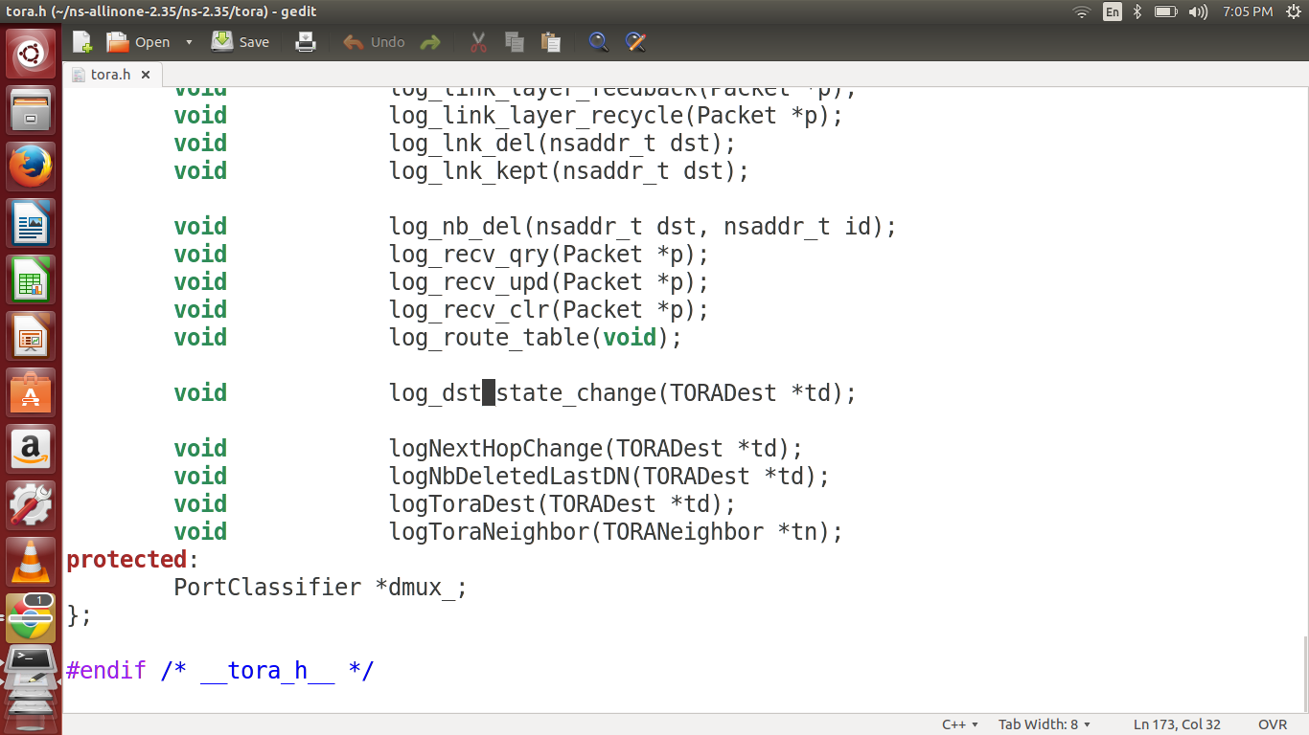
Figure 5.1 Tora.h Change

Change 2: tora.cc
Open the tora.cc and include the following lines in the "int toraAgent::command(intargc, const char*const* argv) " function as indicated in the figure below.
else if (strcmp(argv[1], "port-dmux") == 0) {
dmux_ = (PortClassifier *)TclObject::lookup(argv[2]);
if (dmux_ == 0) {
fprintf (stderr, "%s: %s lookup of %s failed\n", __FILE__, argv[1], argv[2]);
return TCL_ERROR;
}
return TCL_OK;
}
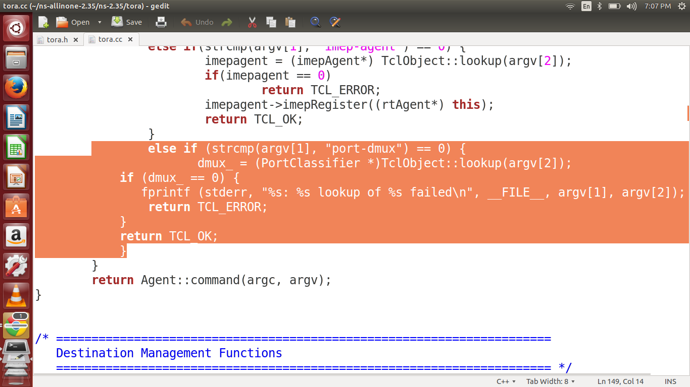
Figure 5.2Tora.cc Change

Change 3: imep.cc
In the file imep.cc, change the following line

rexmitTimer.start(rexat - CURRENT_TIME);

to
if (rexat-CURRENT_TIME<0.000001) // Preventing eternal loop.
rexmitTimer.start(0.000001);
else
rexmitTimer.start(rexat - CURRENT_TIME);

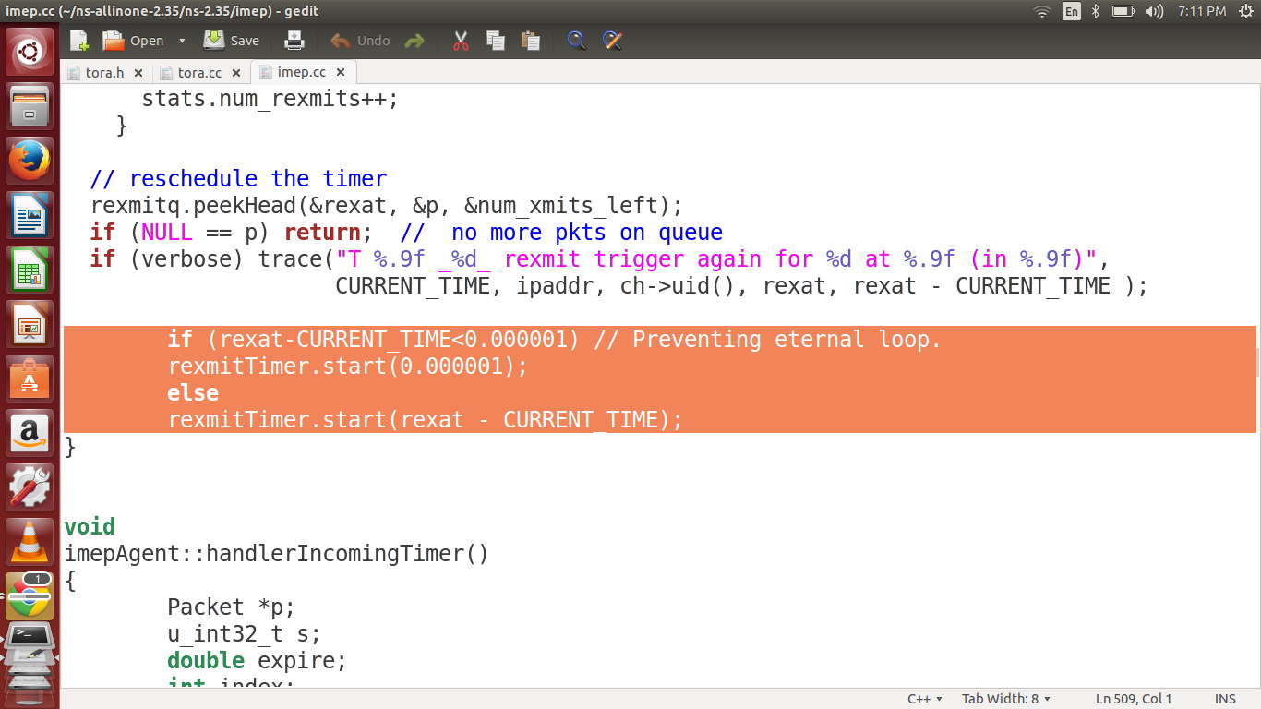
Figure 5.3 IMEP Change

Step 3:
We need to recompile ns2 using the command make from the folder ns-2.35/
Once the changes are made, Open the Terminal and go to ~ns-2.35 and execute the command
prompt$] make
Step 4: Run the tcl file now
$] ns TORA.tcl
This file is generated in Step 1
I will give all these files to you for your simulation.
Copy the tora.cc and tora.h file in your ns-2.35/tora folder
then copy the imep.cc file in to the ns-2.35/imep folder
and then copy the TORA.tcl file in your home folder or any folder.
Then do the compilation $] make
and then run the TORA.tcl file using $] ns TORA.tcl

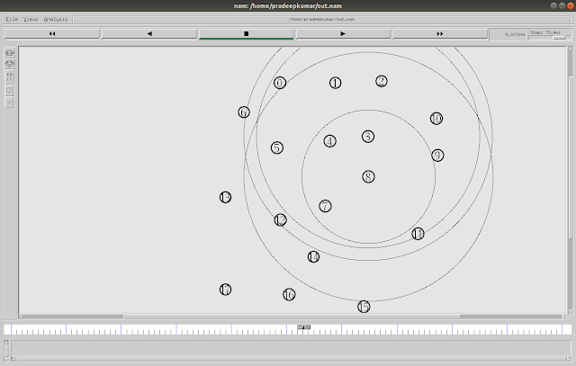
Figure 5.4 TORA Protocol Animation

Simple TORA simulation in NS2 code
# ======================================================================
# Default Script Options
# ======================================================================
set opt(imep) "ON" ;# Enable/Disable IMEP
set opt(ragent) Agent/rtProto/TORA
set opt(pos) NONE ;# Box or NONE
if { $opt(pos) == "Box" } {
puts "*** TORA using Box configuration..."
}
# ======================================================================
Agent instprocinitargs {
$self next $args
}
Agent/rtProtoinstprocinitargs {
puts "DOWN HERE 2"
$self next $args
}
Agent/rtProto/TORA instprocinitargs {
puts "DOWN HERE"
$self next $args
}
Agent/rtProto/TORA set sport_ 0
Agent/rtProto/TORA set dport_ 0
# ======================================================================
proc create-routing-agent { node id } {
global ns_ ragent_ tracefd opt
#
# Create the Routing Agent and attach it to port 255.
#
set ragent_($id) [new $opt(ragent) $id]
set ragent $ragent_($id)
$node attach $ragent [Node set rtagent_port_]
$ragent if-queue [$node set ifq_(0)] ;# ifq between LL and MAC
# now that the Beacon/Hello messages have been
# moved to the IMEP layer, this is not necessary.
# $ns_ at 0.$id "$ragent_($id) start" ;# start BEACON/HELLO Messages
#
# XXX: The routing protocol and the IMEP agents needs handles
# to each other.
#
$ragentimep-agent [$node set imep_(0)]
[$node set imep_(0)] rtagent $ragent
#
# Drop Target (always on regardless of other tracing)
#
set drpT [cmu-trace Drop "RTR" $node]
$ragent drop-target $drpT
#
# Log Target
#
set T [new Trace/Generic]
$T target [$ns_ set nullAgent_]
$T attach $tracefd
$T set src_ $id
$ragent log-target $T
#
# XXX: let the IMEP agent use the same log target.
#
[$node set imep_(0)] log-target $T
}
proc create-mobile-node { id } {
global ns_ chan prop topo tracefd opt node_
global chan prop tracefd topo opt
set node_($id) [new Node/MobileNode]
set node $node_($id)
$node random-motion 0 ;# disable random motion
$node topography $topo
#
# This Trace Target is used to log changes in direction
# and velocity for the mobile node.
#
set T [new Trace/Generic]
$T target [$ns_ set nullAgent_]
$T attach $tracefd
$T set src_ $id
$node log-target $T
$node add-interface $chan $prop $opt(ll) $opt(mac) \
$opt(ifq) $opt(ifqlen) $opt(netif) $opt(ant)
#
# Create a Routing Agent for the Node
#
create-routing-agent $node $id
# ============================================================
if { $opt(pos) == "Box" } {
#
# Box Configuration
#
set spacing 200
set maxrow 7
set col [expr ($id - 1) % $maxrow]
set row [expr ($id - 1) / $maxrow]
$node set X_ [expr $col * $spacing]
$node set Y_ [expr $row * $spacing]
$node set Z_ 0.0
$node set speed_ 0.0
$ns_ at 0.0 "$node_($id) start"
}
}

